**Workshop and Quiz Snapshots:**

**C programming( 9 to 11)**

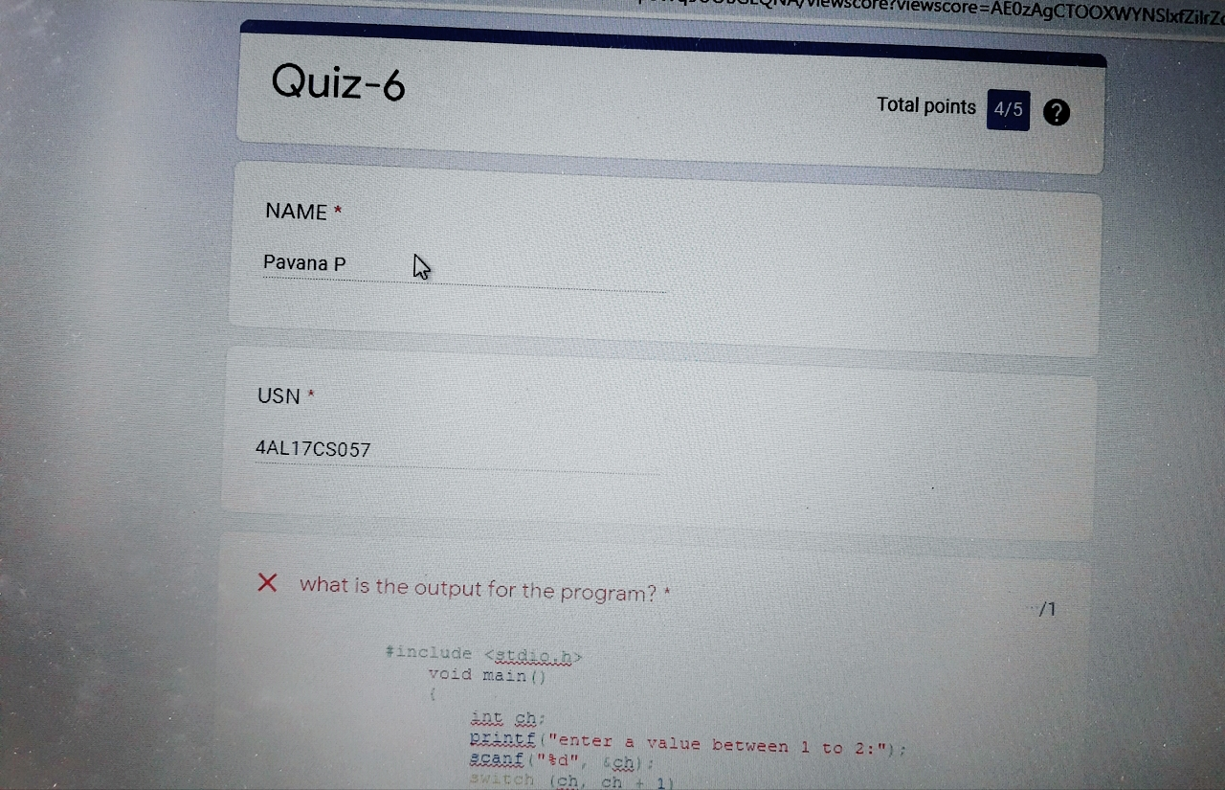



**Python workshop :**

